**Automation shell scripting**

**What is Shell ?**

* Basically Shell is an interpreter, which is used to run your commands.

**Scripting vs. Programming**

I think it’s a pretty esoteric discussion, but you’ll hear people say that BASH Scripting isn’t programming.

However, I have a book, Sams Teach Yourself Shell Programming in 24 Hours, and I’m sure the author, or publisher, or both disagrees.

**Scripting**

BASH uses programs to accomplish tasks. Many of the constructs used to call the programs and accomplish tasks are programming constructs.

Loops, variables, case statements, flow control, and arrays, are all programming constructs available in BASH.

BASH is great for relatively quick, small tasks where speed of processing isn’t much of an issue.

However, some types of work require more speed, or flexibility, or types of programming constructs, than are available in BASH.

Creating a Web Server, or Web Browser would not be pretty or efficient, or maybe even possible using BASH.

Other languages are better suited to many applications.

**Programming**

Full programming languages have functionality and efficiency when used for things they are good at that BASH can’t do as easily or as quickly, or again in some cases even at all.

Object oriented programming lets you modularize and re-use code. You can call a script from another script, but this isn’t the same is instantiating an object in an object oriented programming language.

* **create directory and remove directory**

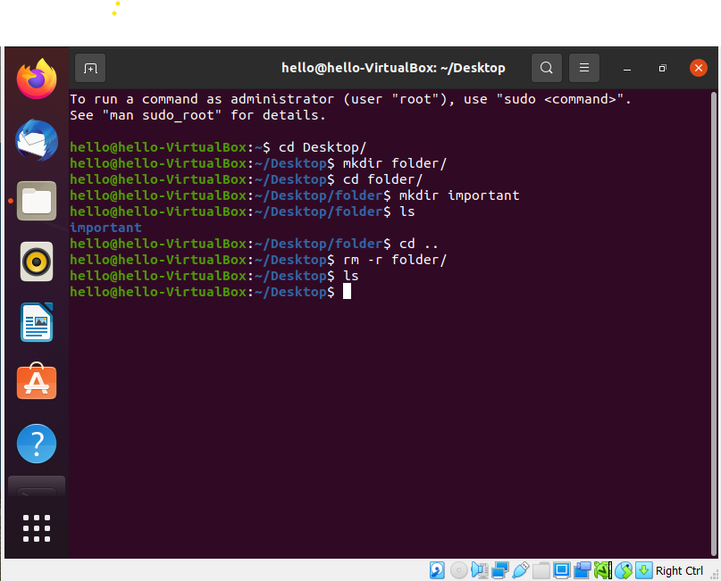

* **created myscript.sh file, this is a script file here I write our script what we plan to make**

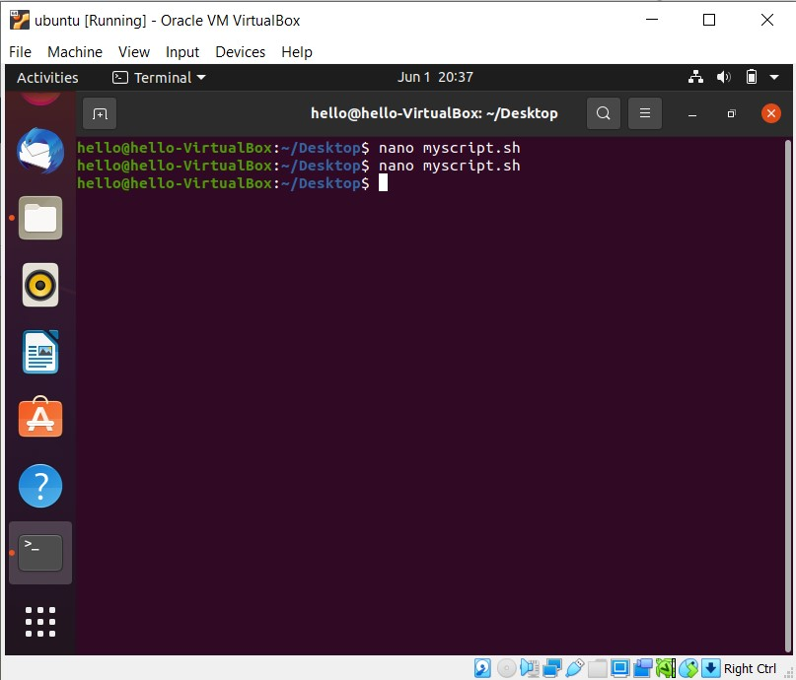

* After write a scrip we save this file

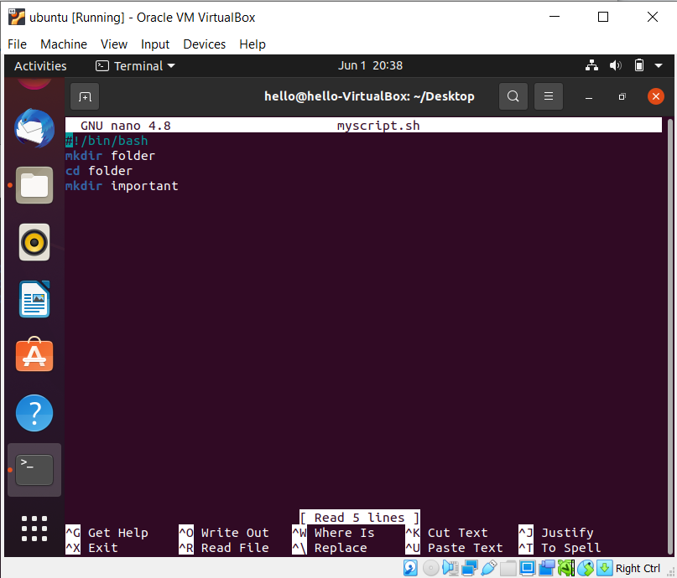

* We have not a permission to execute our file

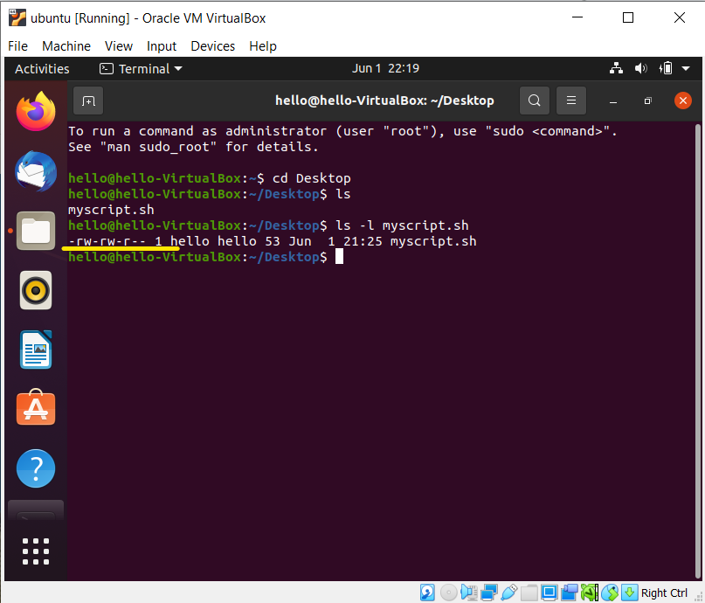

* Now we have a permission to execute our file

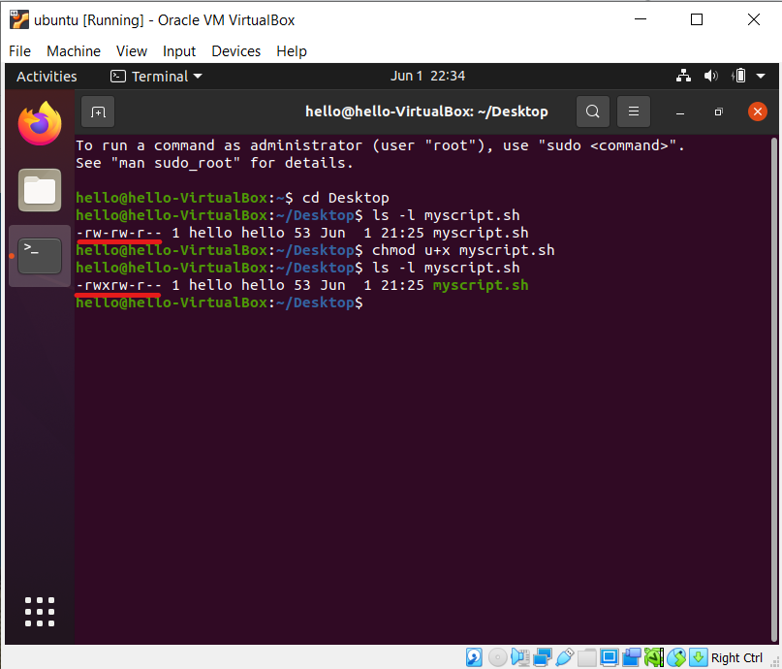

* We use this command to create an empty directory, our empty directory name is folder & in folder we have one more folder name is (Important).

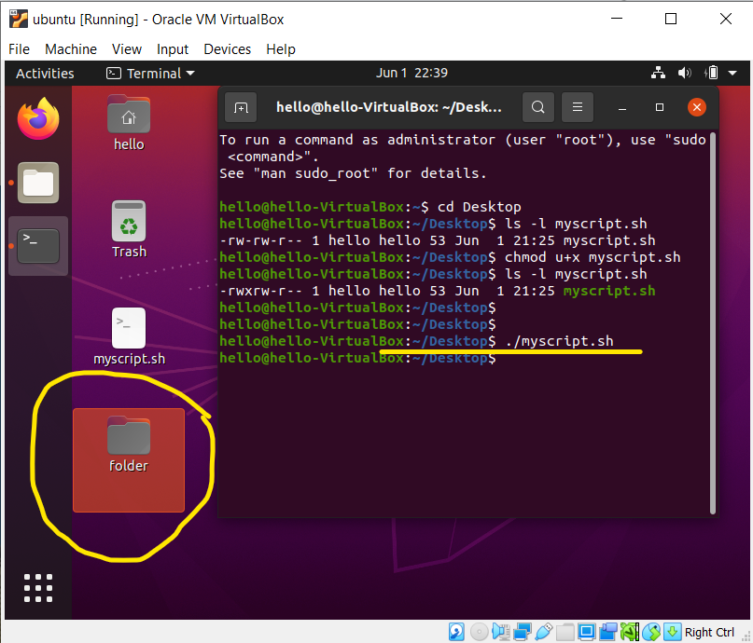

========================== new chapter==============================

* Create a helloworld.sh file in directory

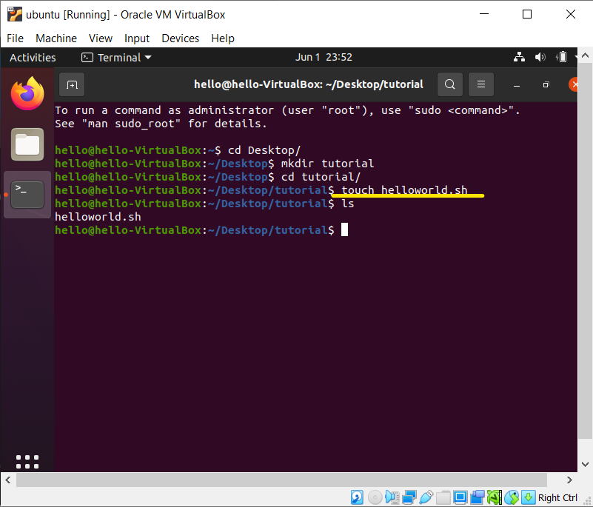

* Create a file name is helloworld.sh, & go to file path and open with text editor.

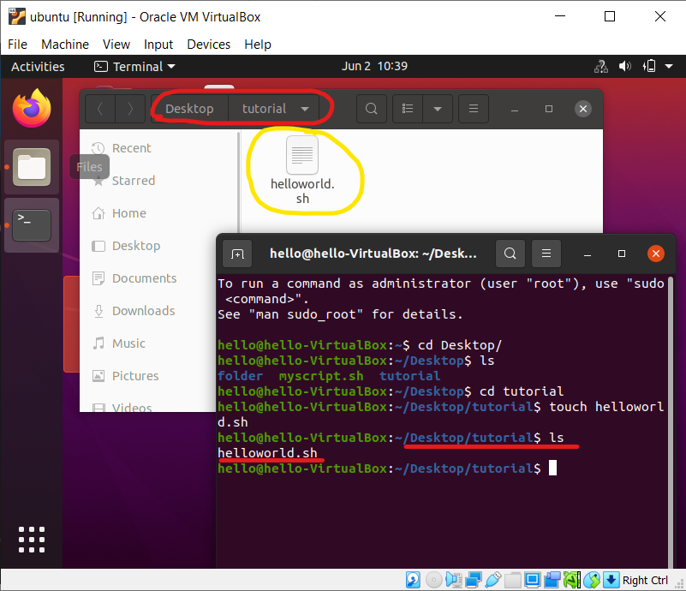

* Open helloworld.sh file in editor and write script & Save file

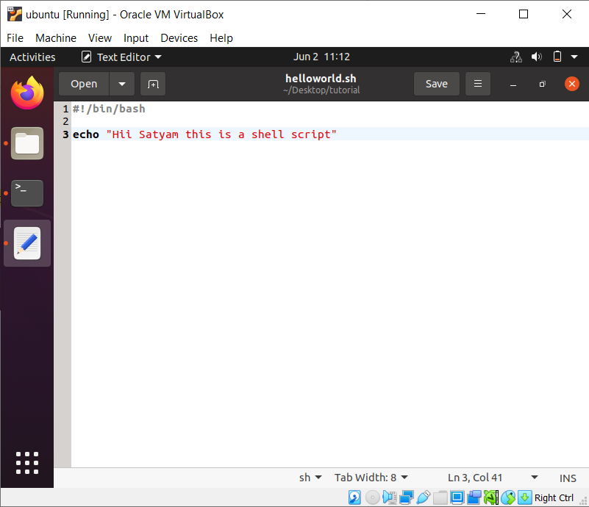

* We have not a permission to execute this file,

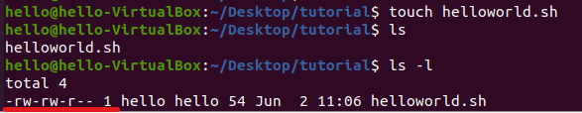

* We have not a permission to execute this file, so firstly we take a permission to execute this file.
* Now we got **x** to execute or file.

